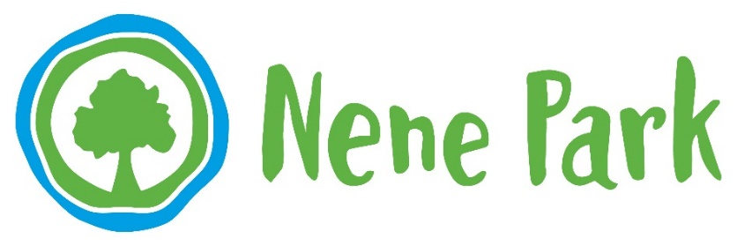

Nene Park Trust, Ham Farm House, Ham Lane, Peterborough PE2 5UU

**Tel: 01733 234193**

**Fax: 01733 361342**

**Date: 9 September 2020**

**Nene Park Trust supports artists and visitors through new**

**Art-In-The-Park programmes**

Nene Park Trust has secured funding for two new art projects in the Park, **42 Words** and **Park Art – Artist in residence programme.**

The innovative **42 Words** project has provided a creative response to the effects of lockdown during Ferry Meadows 42nd year since opening and our renewed appreciation of Peterborough’s parks and greenspaces.

Thanks to the Arts Council Emergency Response Fund, Nene Park Trust supported 14 local artists, many of whom have had work cancelled or postponed due to Covid-19, to create new artworks for the Park. The new artworks created by visual artists, digital artists, street artists, designers and poets are currently being displayed as posters at sites around the Park, encouraging visitors to reflect, laugh and be hopeful about the future. Park visitors, staff, volunteers, schools and community groups were invited to nominate words that described their feelings about lockdown, parks and their feelings towards a sense of community over the last few months and each artist responded to a selection of these words through a series of exciting artworks. There are 42 new artworks to discover with the outdoor exhibitions currently on display at Ferry Meadows, Woodston Reach, Thorpe Meadows and Bluebell Wood.

Louise Thirlwall, Project Officer (Arts and Community) at Nene Park Trust said, *“We wanted to support local artists and involve Park visitors, staff, volunteers and local communities in creating new artworks for the Park. 42 Words is our way of collecting our shared experiences of lockdown and respond creatively to capture this once-in-a-lifetime event through art”.*

***42 Words commissioned Artists are****: Clare Currie, Faith Falayi, Charley Genver, Mark Grist, Katy Hawkins, Paper Rhino (Fiona Cifaldi, Dominc Le-Hair, Jason Duckmanton & Amanda Rigby), Prin Marshall, Lee Mason, Stuart Payn, Charron Pugsley-Hill, Malika Speaks.*

Our new **Park Art – Artist in residence Programme** also funded by Arts Council England, provides new opportunities for artists. Three artists have been invited to create new work in response to the beautiful surroundings of the Park, develop their artistic practice through mentoring sessions and support, and provide visitors with the opportunity to take part in creative activities. They will reside in the Park for 40 days exploring and researching the landscape, heritage and people.

The artists-in-residence are visual artists Caroline Wendling and Madhu Manipatruni and musician and songwriter Yvonne Harris- Hercules. Visitors will have the opportunity to find out more about the work the artists create at events in the Park and online during September and October.

**About the Artists:**

**Yvonne Hercules** is a singer songwriter based in Cambridge. Inspired by folk, blues, rock & soul, her music is a mix of these influences with honest, thought provoking lyrics. Her music often relates to themes that resonate to her, others and the world around her. During her residency Yvonne will be creating a musical piece exploring our human connection to nature and how this relates to issues surrounding climate change.

**Madhu Manipatruni** is a visual artist living in Peterborough. Her practice includes drawing, painting and digital artwork.She likes to use simple materials such as paper, charcoal and her ideas revolve around roots and identity, ideas of beauty and the role of art in the digital age. Madhu is also a practicing Creative Technologist and holds an MA in Creative Technology from DeMontfort University. During her residency Madhu will be experimenting with natural materials found in the Park to make new drawings.

**Caroline Wendling** is a visual artist that creates drawings, prints, installations, walks and performances that explore history and local myths and respond to place. Caroline lives in Cambridgeshire and was born in France, moving to Britain after completing her art studies. She has created commissions for Whitechapel Art Gallery, Kettle’s Yard Gallery, Wysing Arts Centre, and Deron Art Projects. She has recently worked on community projects in Hampton and Bedford. During her residency Caroline will be discovering visitors’ stories about the Park and exploring how visitors interact with nature.

*Find out more at:*

[*www.nenepark.org.uk/art-in-the-park-42-words*](http://www.nenepark.org.uk/art-in-the-park-42-words)

[*www.nenepark.org.uk/artists-in-residence-2020*](http://www.nenepark.org.uk/artists-in-residence-2020)

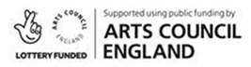

**Notes to Editor:**

1. For more information about this press release please contact Caroline Hartley, Marketing and Communications Officer at Nene Park Trust. 01733 667865 [caroline.hartley@neneparktrust.org.uk](mailto:caroline.hartley@neneparktrust.org.uk)
2. Nene Park Trust is the independent charity that manages over 1,700 acres of land to the west of Peterborough at no cost to the taxpayer, including the 500 acre Ferry Meadows Country Park. The Trust was established in 1988 with the aim of improving the quality of life for Peterborough residents and visitors through providing high quality and accessible open spaces.
3. Nene Park stretches six miles along the valley of the river Nene to the west of Peterborough. The estate includes Thorpe Meadows, with its large rowing course and diverse collection of contemporary sculpture, two 18-hole golf courses at Thorpe Wood and Orton Meadows, and Ferry Meadows Country Park, which contains a wide range of visitor facilities including a watersports centre, areas for camping and caravanning, a visitor centre, gift shop and three children’s play areas. The estate is linked to open countryside by a riverside footpath running west for six miles from the city centre with extensive footpaths, cycleways and horse routes linking to the adjacent villages.
4. Further information on Nene Park and its current events programme is available at [www.nenepark.org.uk](http://www.nenepark.org.uk)/events.
5. Follow Nene Park Trust on Twitter [www.twitter.com/neneparkpboro](http://www.twitter.com/neneparkpboro) and on Facebook at [www.facebook.com/NeneParkPboro](http://www.facebook.com/NeneParkPboro)