Looking to kick-start your career in conservation?
We’re recruiting Volunteer Trainee Reserve Officers

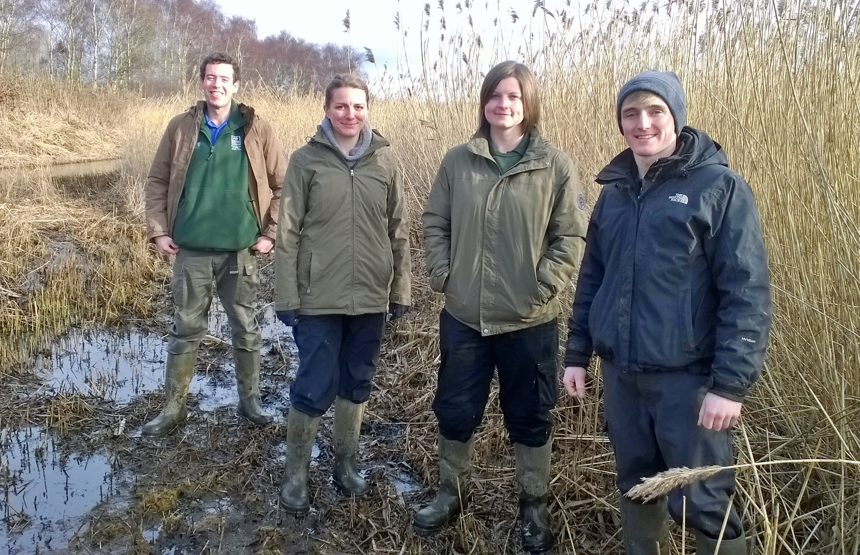

This exciting volunteer post will give you vital experience at one of the UK’s best nature reserves. Based at Rutland Water Nature Reserve’s new purpose-built Volunteer Training Centre you will have the opportunity to get involved in all aspects of the nature reserve; including habitat management, wildlife recording and monitoring and community engagement. You will also have the opportunity to work with the high-profile Osprey project and get involved with the Birdfair.

The role is very practical and this volunteer placement will be suitable for someone who is looking to start a career in conservation as a nature reserve warden or in a similar role. As part of your training you will gain certificates in the use of chainsaws, herbicide application and first aid; and you will be trained in brush cutters, hedge-laying, dry stone walling, charcoal burning, tractor driving and much more.

The placement is based on four days per week for one year (Monday-Thursday), beginning in September 2020.
A living allowance of £70 per week will be paid for each 4 day week completed.

Closing date for applications is the 29th June 2020.
Interviews will take place in July 2020 (confirmation on this date will depend on government restrictions relating to Covid 19).

To apply go to https://www.lrwt.org.uk/jobs/volunteer-trainee-reserve-officer for further enquiries please email Joe Davis at jdavis@lrwt.org.uk

